<Online Flight Tracking System>

Software Modeling

<Phase 1>

<March 18, 2018>

<Abdulrhman Ali Alsenedi/436101804>

<Abdulmajeed Saleh Alaskar/436104024>

<Khalid Abdulhadi Alqahtani/434105057>

<Asim Mohammed Alali/435102899>

# 1. Introduction

The travelers of flights don’t have exact information about the flight timing, therefore, you are required to design and implement a system using which the users through computer or smartphone get the information about flight timings and if the flight is on time and not. Also the system should allow the users to web-check in if the user has no check in luggage and only hand carry. The flights live information can be procured form more than 2 sources viz., the airport authority server and online free sources such as adware flight, to ensure the accuracy of the information based on which users can plan their travel.

## 1.2 Scope

The software product to be developed is the Online Flight Tracking System (OFTS), the airline tracking website is an application stored in the Airport Authority server. The purpose of the website is to resolve the client to allow website users to perform tasks related to booking airline flight. users are only allowed to search for available flights. Member users have the right to search for available flights, admin can create a plan and delete a flight and to edit their member information. admin is required to login in to their account prior to flight booking.

## 1.4 References

[Online flight booking srs document](https://www.slideshare.net/manthankdesai/online-flight-booking-srs-document) .

[Flight Planning and Management System Software Requirements Specification](http://www.cs.utep.edu/cheon/cs4311/data/srs-s15-v10.pdf) .

## 2.1 Functional Requirements

### 2.1.1 The admin shall be able to create a flight plan.

**2.1.2 The system shall allow the admin to login.**

**2.1.3 The user shall be able to web-check in of his booking.**

### 2.1.4 The user shall be able to view his Flight plan.

### 2.1.5 The user shall be able to view the cancelation of Flights .

### 2.1.6 The user shall be able to search for flights details using flight number.

### 2.1.7 The user shall be able to search for flights details using Airport name.

### 2.1.8 The user shall be able to search for flights details using destination and origin.

### 2.1.9 The user shall be able to view a live status.

## 3. Class Diagram

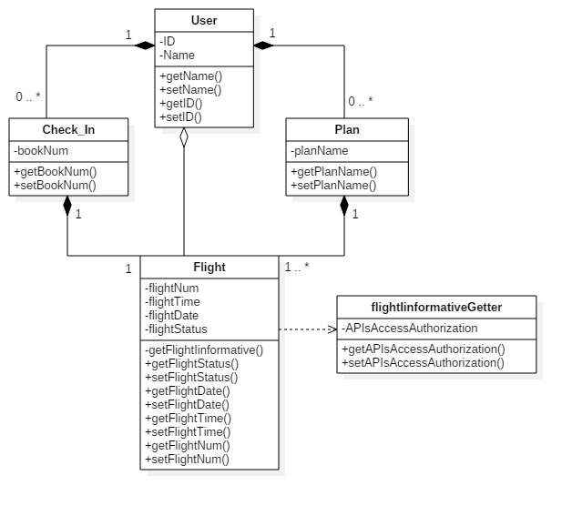

## 4 Use Case Diagram

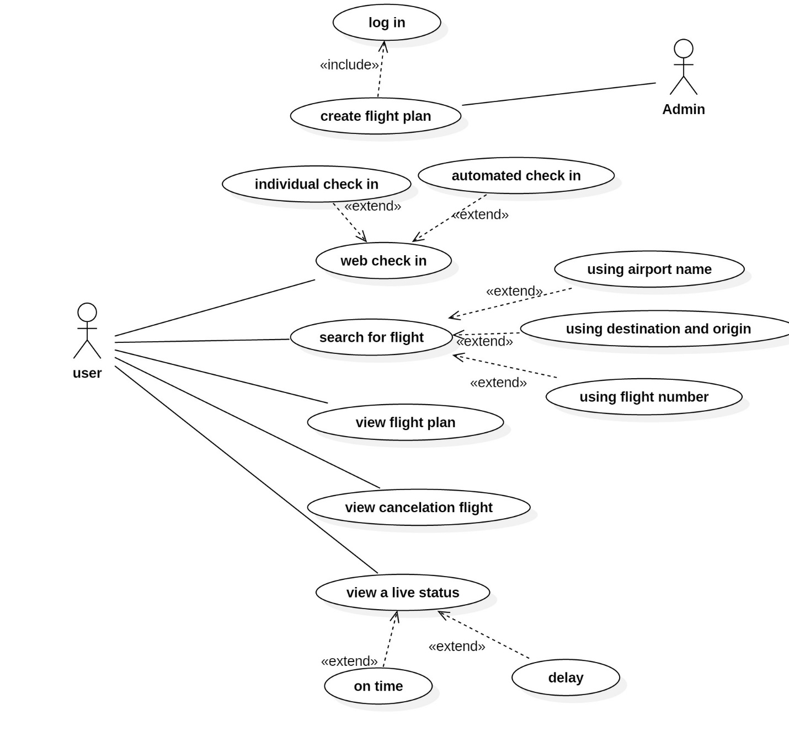

## 5. Use Case Description

|  |  |
| --- | --- |
| Use case name | Create flight plan |
| Description | This use case allows The admin to add flight plans to the system for the user so he/she can track their flight. |
| Primary actor | Admin |
| Precondition | The admin must log in to the system first. |
| Flow of events | |  |  | | --- | --- | | Actor | system | | 1-Admin log in to the system.  2-add information of the flight to its plan such as: flight number, airport name, origin and destination, departure and arrival so the users can track their flights.  3-upload the flight plan to the system. | 3.1 display flight plans to the user.  4-remove the flights that has been arrived. | |
| Alternative Flow | -wrong Info for the admin to log in.  -this flight does not exist. |
| Post-condition | All flight information must be added to the flight plan. |